

(All rights reserved)
DEPARTMENT OF STATISTICS & ACTUARIAL SCIENCES
SCHOOL OF PHYSICAL & MATHEMATICAL SCIENCES
FIRST SEMESTER, 2025/2026 ACADEMIC YEAR

M.SC. APPLIED STATISTICS (Weekend Cohort)
ASTA 607: Computational Statistics

NAME: SANDRA KUMAH
STUDENT ID: 22424433

- Data Description
The crabs data frame has 200 rows and 8 columns, describing 5 morphological measurements on 50 crabs each of two colour forms and both sexes, of the species Leptograpsus variegatus. The dataset contains variables like Species, Sex, index, frontal lobe size, rear width, carapace length, carapace width, and body depth.

- The crab dataset contains 200 observations with 8 variables. The dataset contains 2 categorical and 5 numerical variables, and 1 integer. The datatypes are as follows;
Categorical variables: Species and Sex
Numerical Variables: FL, RW, CL, CW, BD
Integer variable: Index

C. Results
Table 1
FEMALE MALE

BLUE 50 50

ORANGE 50 50

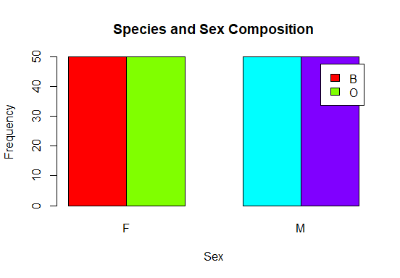

The dataset distribution indicates that the group composition defined by species and sex is perfectly balanced, with 50 observations per group. This ensures that comparisons across groups are not influenced by unequal group sizes, reducing potential bias and improving the validity and predictive performance of subsequent statistical analyses

Question 2

Output
Figure 1
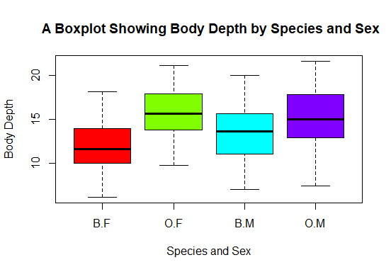

Results

sp sex BD.Mean BD.Median BD.SD BD.IQR BD.Min BD.Max
1 B F 11.816000 11.600000 2.752465 3.850000 6.100000 18.100000
2 O F 15.632000 15.650000 2.752620 4.050000 9.700000 21.100000
3 B M 13.350000 13.600000 3.199888 4.600000 7.000000 20.000000
4 O M 15.324000 15.000000 3.527187 4.825000 7.400000 21.600000

Interpretation

Species O individuals have higher body depth than species B for both sexes. Within species B, males have higher body depth than females, whereas in species O, the difference between males and females is minimal. The spread of body depth is generally larger in groups with higher median values, particularly in O.M. Overall, both species and sex influence body depth, with species being the stronger factor in distinguishing group differences.

Question 3
- Code
figure 2

Results

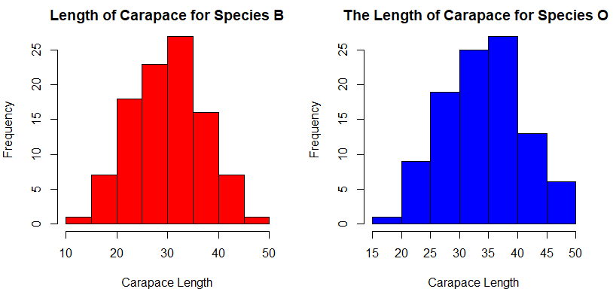

Interpretation
Both species are roughly centered around their mean CL, with species O having higher values. Species O shows a slightly wider spread than species B. Histograms are mostly symmetric, though some small right skew may occur for both species. Both distributions are unimodal (single peak).
Carapace length differs between species, with species O having higher values, but the overall shape of the distribution is roughly symmetric and unimodal for both species. This suggests no extreme skew or multiple subgroups within a species based on CL.

Question 4
Results

table 2
sp sex FL RW CL CW BD
1 B F 13.270 12.138 28.102 32.624 11.816
2 O F 17.594 14.836 34.618 39.036 15.632
3 B M 14.842 11.718 32.014 36.810 13.350
4 O M 16.626 12.262 33.688 37.188 15.324

- Output
figure 3
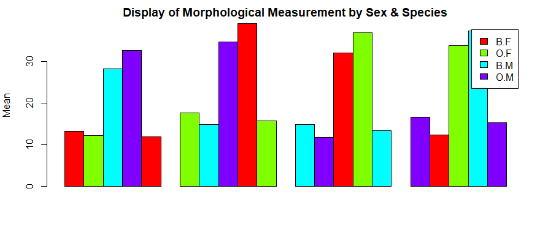
Interpretation

RW shows the greatest sex-based variation across both species. Males and females differ noticeably in RW, with females having proportionally wider rear widths to accommodate egg brooding. Among the five morphological measurements, RW is the most sexually dimorphic.
FL exhibits the least sex-based variation. Mean FL values are very similar between males and females within each species, indicating low sexual dimorphism. These patterns align with biological expectations: the rear width is adapted in females for reproductive purposes, while frontal lobe size is more conserved between sexes.

Results
figure 4
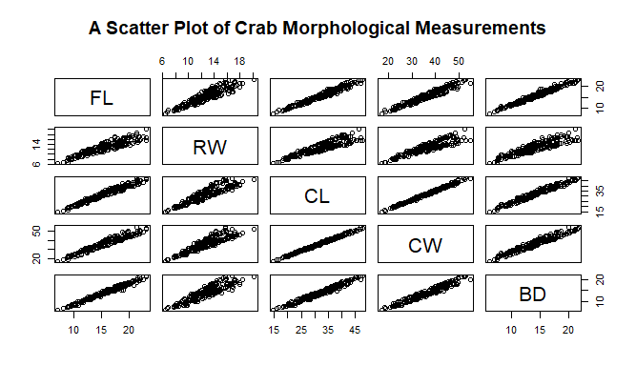
Interpretation
All five measurements are strongly positively correlated. That is, Carapace length (CL), Carapace Width (CW), Body Depth (BD), Frontal Lobe length (FL), and Rear Width (RW) show higher values and increase together, indicating overall crab size. That is, as one measurement increases, the others tend to increase as well. That is to say, larger crabs tend to have larger values for all morphological traits.

